**St Mark’s Holy Kids and**

**Holy Kids 2**



Weekend 6th/ 7th Feb 2021

Hello everyone,

**In the beginning….**

**In the beginning the Word already existed; the Word was with God, and the Word was God. From the very beginning the Word was with God. Through him God made all things; not one thing in all creation was made without him. The Word was the source of life, and this life brought light to people. The light shines in the darkness, and the darkness has never put it out. John 1:1-5**

This is a very difficult passage of the Bible to understand, indeed, i’m not sure if any of us can fully understand this!

It was written by one of Jesus’ disciples, to describe Jesus. John calls Jesus ‘the Word’ and explains how the Word (Jesus) was with God from the beginning of time – long before Jesus came to earth.

This really takes some thinking about – if you want to let us know what this means to you, or to ask us any questions please get in touch.

There’s a creative craft activity included with this pack to help us to imagine what the beginning of the world might have been like, and two colouring sheets, one easy and one more difficult to do.

We hope you enjoy this pack, why not send us a photo of your craft or your colouring, and we will post it on our Holy Kids website page <http://stmarks.wrexhamparish.org.uk/index.php/holy-kidz/> . You can contact us on 07933 667065 or via Jonathan our vicar’s email address: [jonathan@plwyfwrecsam.org.uk](mailto:jonathan@plwyfwrecsam.org.uk). Please state if you give us permission to upload your pictures to our website and social media.

As we’re sure you know, we can’t recommence our Holy Kids or Holy Kids 2 groups in person at the moment due to Welsh Government restrictions. We’ll keep you updated and let you know when we are able to restart.

We hope you enjoy these activities; if you have any feedback, or if you’d rather not receive activity packs in the future please let us know by texting 07933 667065.

Thank you,

**Elaine Smith and all the leaders,**

**St Mark’s Church Holy Kids**

**Make a picture to imagine the beginning of the World**

In your pack this week there is some plain paper and some teabags! These aren’t your usual cuppa though; they are what we call fruit tea bags.

**How to make your picture**

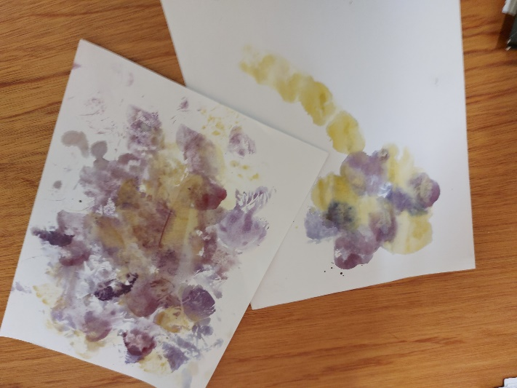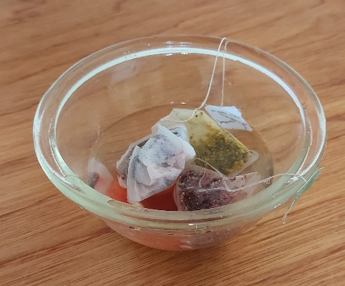Fill a small bowl with some lukewarm water and put the teabags in the bowl. When they have been there a couple of minutes, squeeze them out well, and you will be able to use them to make beautiful coloured marks on your paper. You could imagine all sorts of colours swirling around when God was creating the earth, or perhaps you would like to use the teabag prints to make a flower or an animal of some sort….and don’t forget, Jesus was right there with God at the beginning of everything.

Have fun, we’d love to see your designs – I’m sure you can do better than me!



